**Statistical Analysis of UV Based and Alcohol Disinfectant Data**

All statistical analyses were performed using R Studio v 4.2.1 and all test of significance were evaluated at 5% level.

Effectiveness of UV based and Alcohol based disinfectant were measured based on number of colonies in different treatments. Different treatments were replicated thrice and were compared to a baseline treatment wherein the agar plate was not exposed to UV or Alcohol. Results revealed that the baseline treatment was relatively higher compared to Alcohol based and UV based treatments. This suggests that Alcohol based and UV based disinfectant were more effective in terms of bacterial inhibition.

**Statement of the Problem 1**

What is the significant difference between ultraviolet-based disinfectant and alcohol-based disinfectant in terms of their effectiveness?

**Null Hypothesis:** There is no significant difference between UV based disinfectant and Alcohol based disinfectant in terms of their effectiveness.

**Alternative Hypothesis:** There is a significant difference between UV based disinfectant and Alcohol based disinfectant in terms of their effectiveness.

**Result of Two-Samples Wilcoxon Test**

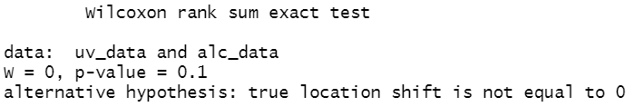

**Conclusion**

Since the p-value of 0.1 is greater than 5% level of significance (0.05), there is enough evidence to conclude that UV and Alcohol based disinfectant exhibit no significant difference when it comes to their effectiveness.

**Statement of the Problem 2**

What is the significant effect of ultraviolet intensity to be use in terms of its effectiveness?

**Null Hypothesis:** There is no significant effect of UV intensity to be use in terms of effectiveness.

**Alternative Hypothesis:** There is a significant effect of UV intensity to be use in terms of effectiveness.

**Result of One-Sample Wilcoxon Test**

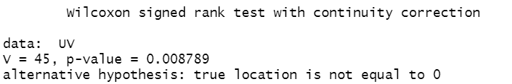

**Conclusion**

Since the One-Sample Wilcoxon Test resulted a p-value of 0.0088, and is less than 5% level of significance (0.05), it was therefore concluded that UV intensity has a significant effect in terms of effectiveness. This result supports the comparison of findings of Baseline treatment and UV based treatments in terms of bacterial inhibition since number of colonies from UV based treatments were lower than those from the former.

**Statement of the Problem 3**

What is the significant difference among the different duration in terms of its effectiveness?

**Null Hypothesis:** There is no significant difference among the duration of 10 seconds, 20 seconds, and 30 seconds in terms of its effectiveness.

**Alternative Hypothesis:** There is a significant difference among the duration of 10 seconds, 20 seconds, and 30 seconds in terms of its effectiveness.

**Result of Kruskal-Walis Test**

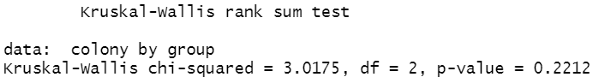

**Conclusion**

Since the Kruskal-Walis test yields a p-value of 0.2212, and is greater than 5% level of significance (0.05), therefore, the different durations of UV exposure show no significant difference in terms of effectiveness.